Real Estate Firm Database

1. Menentukan entitas

* Sales_offices
* Employees
* Relationship
* Clients
* Properties
* Ownership

1. Menentukan atribut

* Sales_offices : off_number, off_address, off_city, off_state, off_zip, manager_id
* Employees : emp_id, emp_name, emp_id_numb, so_id
* Relationship : emp1_id, emp2_id, marriage_date
* Clients : client_id, client_name, client_id_numb
* Properties : prop_id, prop_address, prop_city, prop_state, prop_zip, prop_so_id
* Ownership : prop_id, owner_id, percent_owned

1. Menentukan relasi

Sales_offices (1) ------------- (M) employees

Relationship (1) ---------------- (M) employees

Clients (1) ----------------- (M) properties

Ownership (M) --------------- (1) properties

Sales_offices (1) -------------- (0 - M) properties

1. ERD

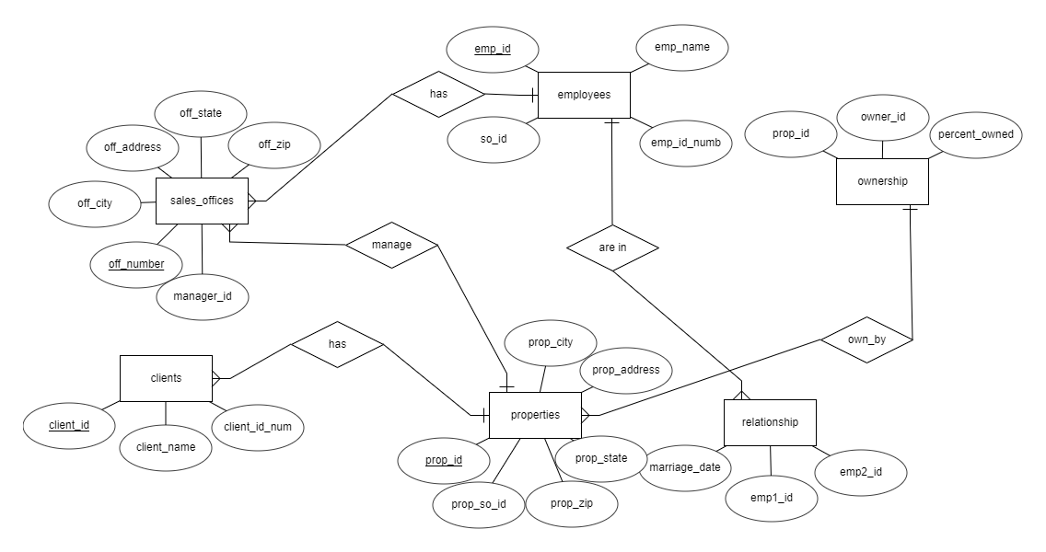

1. Table atribut

* Sales_offices

|  |  |  |  |
| --- | --- | --- | --- |
| Attribute_name | Type | Size | Description |
| off_number | Int | - | Primary key, auto inc |
| off_address | Varchar | 100 |  |
| off_city | Varchar | 50 |  |
| off_state | Varchar | 50 |  |
| off_zip | int | - |  |
| manager_id | Int | - | Foreign key, manager kantor wilayah |

* Employees

|  |  |  |  |
| --- | --- | --- | --- |
| Attribute_name | Type | Size | Description |
| emp_id | Int | - | Primary key, auto inc |
| emp_name | Varchar | 100 |  |
| emp_id_numb | Int | - |  |
| so_id | Int | - | Foreign key, tempat kerja karyawan |

* Relationship

|  |  |  |  |
| --- | --- | --- | --- |
| Attribute_name | Type | Size | Description |
| emp1_id | Int | - | Foreign key, pasangan dari emp2 |
| emp2_id | Int | - | Foreign key, pasangan dari emp1 |
| marriage_date | Date | - | Tanggal emp1 dan emp2 menikah |

* Clients

|  |  |  |  |
| --- | --- | --- | --- |
| Attribute_name | Type | Size | Description |
| client_id | Int | - | Primary key, auto inc |
| client_name | Varchar | 100 |  |
| client_id_numb | Int | - | Identitas klien (ktp, etc) |

* Properties

|  |  |  |  |
| --- | --- | --- | --- |
| Attribute_name | Type | Size | Description |
| prop_id | Int | - | Primary key, auto inc |
| prop_address | Varchar | 100 |  |
| prop_city | Varchar | 50 |  |
| prop_state | Varchar | 50 |  |
| prop_zip | Int | - |  |
| prop_so_id | Int | - | Foreign key, id kantor wilayah pengurus |

* Ownership

|  |  |  |  |
| --- | --- | --- | --- |
| Attribute_name | Type | Size | Description |
| prop_id | Int | - | Foreign key |
| owner_id | Int | - | Foreign key |
| percent_owned | Float | - | Presentase kepemilikan |

Q2 Answer:

1. Tidak adanya kardinalitas didalam erd tersebut
2. Kurang lengkapnya atribut dan tidak adanya primary key (entah erd belum selesai)
3. Nama atribut dan nama entitas terdiri dari 3 kata
4. Nama relasi bukan kata kerja

